Student Name: Eric Vara

**Final Project: Histogram**

Problem Description:

Develop a program that displays a histogram to show the occurrences of each letter in a text area. The histogram should show the occurrences of each letter in a text file, as shown in the following figure. Assume that the letters are not case sensitive.

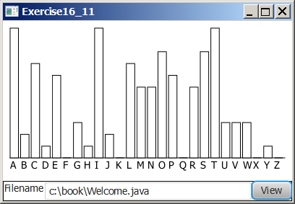

* Place a pane that will display the histogram in the center of the frame.
* Place a label and a text field in a panel, and put the panel in the south side of the frame. The text file will be entered from this text field.
* Pressing the Enter key on the text field causes the program to count the occurrences of each letter and display the count in a histogram.
* Input file: Chapter16ProgrammingAssignment5File.txt

Submit the following items:

1. Compile and Submit (you must submit the program regardless whether it complete or incomplete, correct or incorrect)

2. Fill in self-evaluation:

1. Can your program create the UI? No
2. Can your program handle action event from the text field? No
3. Can your program read text from the file? No
4. Can your program count the occurrence of letters? No
5. Can your program display 26 vertical bars? No
6. Can your program resize the bars when the user resizes the frame? No
7. Can your program display 26 vertical bars correctly? No